SPP10 Template

[Title: 14pt centered bold - elements, and acronyms should be capitalized]
Jane Doe¹, John Doe²
1. Institution/Organization, address
2. Institution/Organization, address
E-mail: provide one email address
[Author name(s):10pt Centred Bold; presenting author’s name underlined]
[Author’s affiliation and full address: 8pt centered]
[E-mail address: 8pt centered]
This abstract template is for submissions to the 10th International Conference on Surface Plasmon Photonics (SPP10). The abstract template is to assist your submission and ensure a uniform style throughout the handbook. To maintain the formatting of this document you can type over the text.
Please ensure your abstract is within the one page limit, including equations, drawings, figures and references. Abstracts must contain a title, author names and their organizations. Paper size should be Letter (21.59 cm x 27.94 cm). Margins should be set for a 2.54 cm top, bottom, left, and right. Do not add page numbers. Avoid asterisks, acknowledgements, job descriptions or footnotes.
The text style is as follow: Please use text font - Times New Roman and single spacing throughout the document. The title is 14pt centered bold, 12pt spacing after title. The author name(s) is 10pt centered bold, 12pt spacing between author name(s) and the abstract. Author name(s): first name then last name in full; the organization(s) and one contact email address to follow. Enter the name of the presenting author first and underlined. All body text is 10pt, alignment Justified, 12pt spacing after each paragraph.
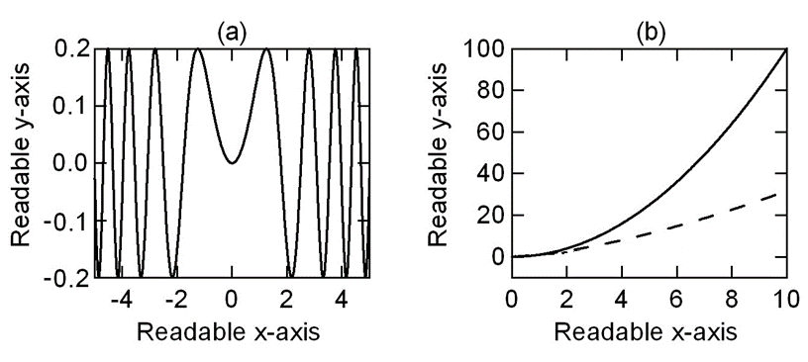
Figures should have a caption and be readable. Figures should be placed as close as possible to where they are mentioned in the text. Figures can be provided in greyscale or colors. Figure captions should be centred beneath figures, in an 8pt font and indented 1 cm on both sides and justified on both right and left sides. Sans Serif Fonts such as Arial can be used in Figures.

Fig. 1 The abbreviation “Fig.” (for figure) should appear first, followed by the figure number, a period, and then the figure caption.

References should be formatted in the style given below. References should appear at the end of the abstract and follow a numerical order of appearance in the text. The references are 8pt, left-aligned, 0pt spacing before and after. Within the main text, references should be designated by a number in brackets [1], and they should precede a comma or period [2]. Two references cited at once should be included together [2,3], separated by a comma, while three or more consecutive references should be indicated by the bounding numbers and a dash [1–3].
Thank you for complying with the formatting provided here.

References
[1] Authors should be listed surname first, followed by a comma and initials of given names. Year. Italicised Abbreviated Journal Title, Volume number, page numbers.
[2] Authors should be listed surname first, followed by a comma and initials of given names. Chapter name, in Italicised Book Title, Editors should be listed surname first, followed by a comma and initials of given names. Year, Publisher, Place, page numbers.

